Date: 26/03/26
📊 Final Count:
🟢 Bullish | 99
🔴 Bearish | 1
Total | 100

🟢 BULLISH TRADES --- 99
1 | ABB
2 | APLAPOLLO
3 | ADANIENT
4 | ADANIGREEN
5 | ADANIPORTS
6 | ABCAPITAL
7 | AMBER
8 | AMBUJACEM
9 | APOLLOHOSP
10 | ASHOKLEY
11 | ASIANPAINT
12 | AUROPHARMA
13 | DMART
14 | BSE
15 | BAJAJFINSV
16 | BANDHANBNK
17 | BANKINDIA
18 | BHARATFORG
19 | BHEL
20 | BIOCON
21 | BLUESTARCO
22 | BOSCHLTD
23 | CHOLAFIN
24 | COFORGE
25 | COLPAL
26 | CAMS
27 | CONCOR
28 | CROMPTON
29 | CUMMINSIND
30 | DABUR
31 | DELHIVERY
32 | DIXON
33 | DRREDDY
34 | ETERNAL
35 | EICHERMOT
36 | NYKAA
37 | FORTIS
38 | GMRAIRPORT
39 | GODREJPROP
40 | GRASIM
41 | HDFCAMC
42 | HAVELLS
43 | HEROMOTOCO
44 | HINDPETRO
45 | HINDZINC
46 | POWERINDIA
47 | IIFL
48 | ITC
49 | IEX
50 | IRCTC
51 | IREDA
52 | INDUSINDBK
53 | NAUKRI
54 | INDIGO
55 | JSWSTEEL
56 | JUBLFOOD
57 | KEI
58 | KPITTECH
59 | KAYNES
60 | KFINTECH
61 | LTM
62 | LT
63 | LAURUSLABS
64 | LICI
65 | LUPIN
66 | MANAPPURAM
67 | MANKIND
68 | MARICO
69 | MARUTI
70 | MAXHEALTH
71 | MPHASIS
72 | MUTHOOTFIN
73 | NBCC
74 | NCC
75 | NHPC
76 | NMDC
77 | NTPC
78 | NUVAMA
79 | OBEROIRLTY
80 | PAYTM
81 | OFSS
82 | PGEL
83 | PNBHOUSING
84 | PATANJALI
85 | PIDILITIND
86 | POLYCAB
87 | PNB
88 | RECLTD
89 | RELIANCE
90 | SHREECEM
91 | SRF
92 | SAMMAANCAP
93 | SIEMENS
94 | SOLARINDS
95 | SBIN
96 | SUNPHARMA
97 | SUPREMEIND
98 | TATACONSUM
99 | TVSMOTOR
🔴 BEARISH TRADES --- 1
1 | PFC

Trade Taken
🟢 BULLISH SIGNAL --- BSE
Crossover : 2026-03-25 09:30
Pullback : 2026-03-25 11:15
Confirm : 2026-03-25 11:30
Nifty Bias : ⚠️ CHOPPY (Choppy ⚠️)
🟢 BULLISH SIGNAL --- BANDHANBNK
Crossover : 2026-03-25 11:45
Pullback : 2026-03-25 13:00
Confirm : 2026-03-25 13:30
Nifty Bias : ⚠️ CHOPPY (Choppy ⚠️)
🟢 BULLISH SIGNAL --- BHARATFORG
Crossover : 2026-03-24 14:30
Pullback : 2026-03-24 15:00
Confirm : 2026-03-25 09:15
Nifty Bias : ⚠️ CHOPPY (Choppy ⚠️)
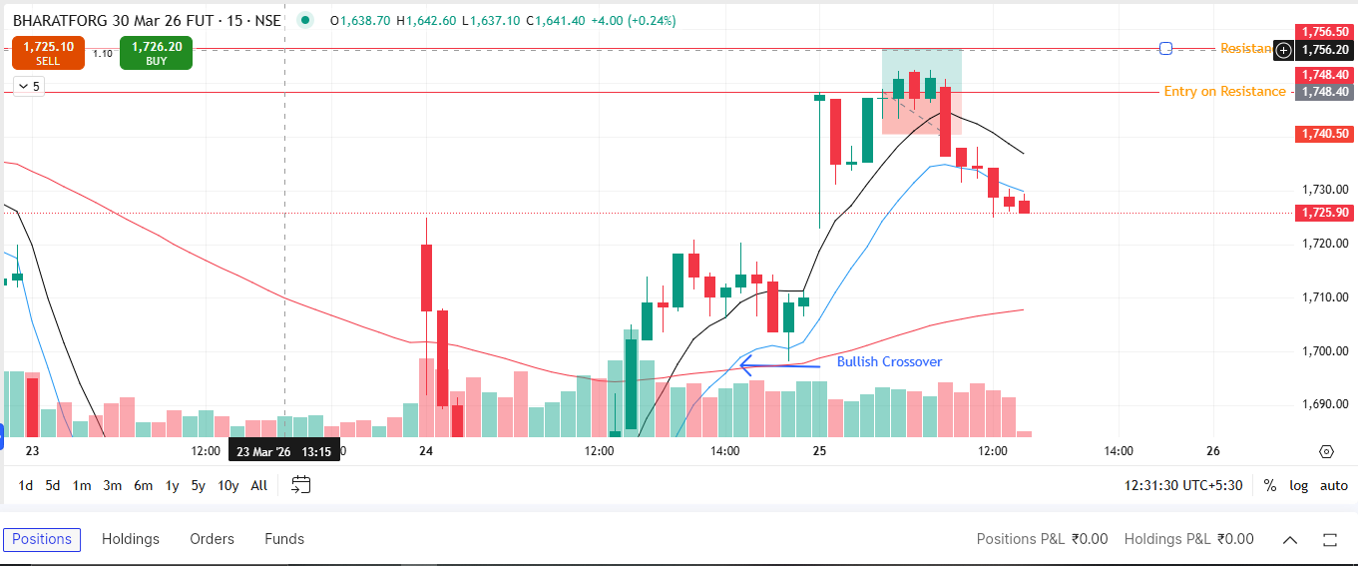
🟢 BULLISH SIGNAL --- CAMS
Crossover : 2026-03-24 13:45
Pullback : 2026-03-24 14:45
Confirm : 2026-03-25 09:15
Nifty Bias : ⚠️ CHOPPY (Choppy ⚠️)
🟢 BULLISH SIGNAL --- OFSS
Crossover : 2026-03-24 12:00
Pullback : 2026-03-24 15:00
Confirm : 2026-03-25 09:15
Nifty Bias : ⚠️ CHOPPY (Choppy ⚠️)
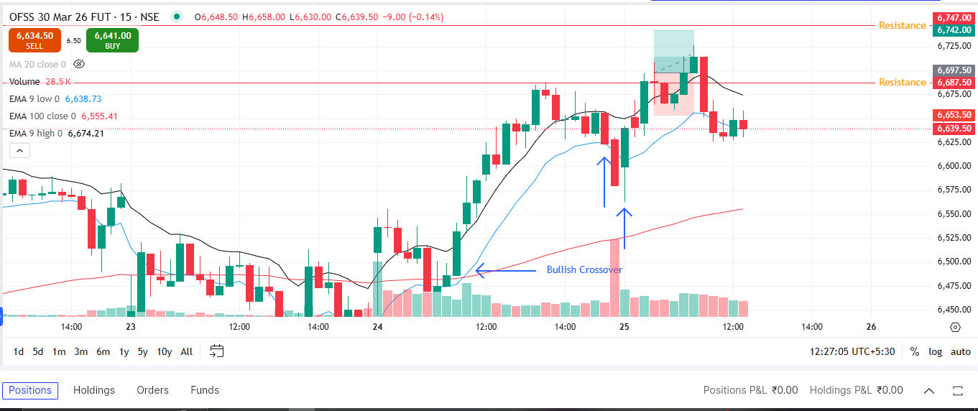

Trade Not Taken
🟢 BULLISH SIGNAL --- ABB
Crossover : 2026-03-25 09:30
Pullback : 2026-03-25 11:30
Confirm : 2026-03-25 12:15
Nifty Bias : ⚠️ CHOPPY (Choppy ⚠️)
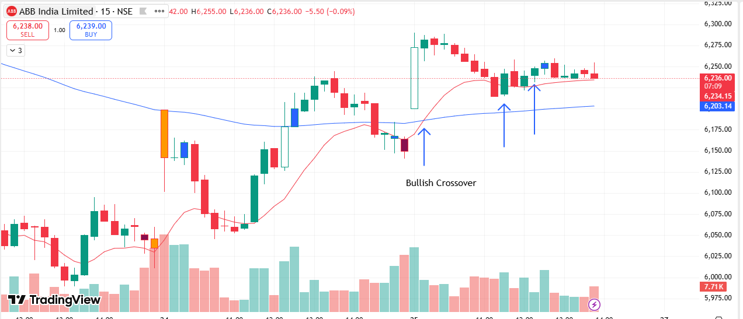
🟢 BULLISH SIGNAL --- APLAPOLLO
Crossover : 2026-03-24 13:45
Pullback : 2026-03-25 11:30
Confirm : 2026-03-25 12:15
Nifty Bias : ⚠️ CHOPPY (Choppy ⚠️)
🟢 BULLISH SIGNAL --- ADANIENT
Crossover : 2026-03-25 12:00
Pullback : 2026-03-25 14:15
Confirm : 2026-03-25 14:30
Nifty Bias : ⚠️ CHOPPY (Choppy ⚠️)
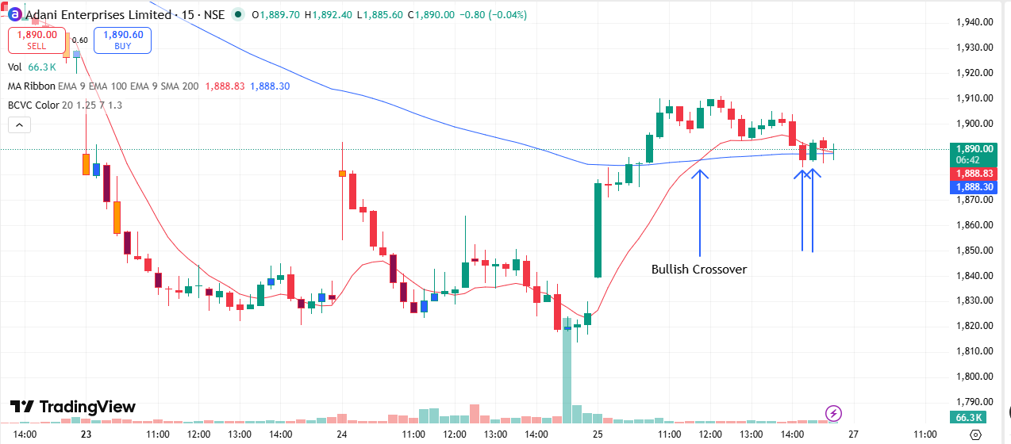
🟢 BULLISH SIGNAL --- ADANIGREEN
Crossover : 2026-03-25 09:45
Pullback : 2026-03-25 13:00
Confirm : 2026-03-25 13:15
Nifty Bias : ⚠️ CHOPPY (Choppy ⚠️)
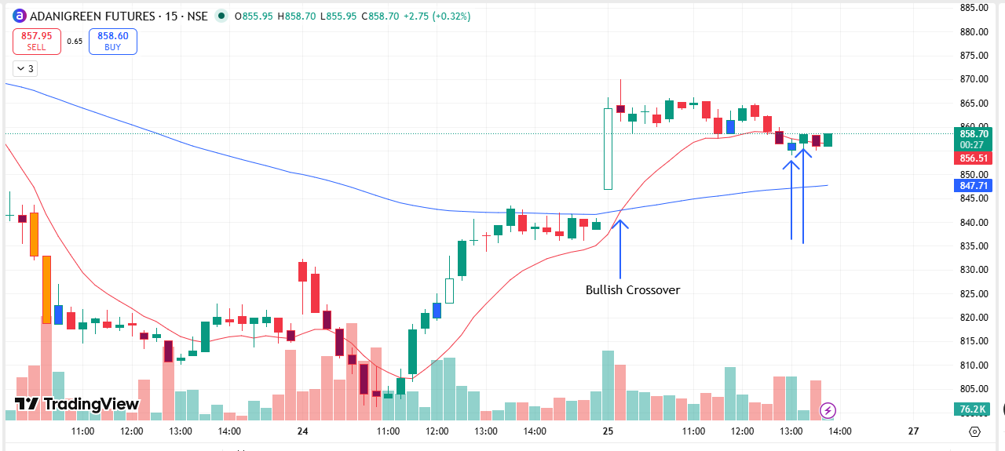
🟢 BULLISH SIGNAL --- ADANIPORTS
Crossover : 2026-03-25 09:30
Pullback : 2026-03-25 13:00
Confirm : 2026-03-25 13:15
Nifty Bias : ⚠️ CHOPPY (Choppy ⚠️)
🟢 BULLISH SIGNAL --- ABCAPITAL
Crossover : 2026-03-25 10:00
Pullback : 2026-03-25 11:30
Confirm : 2026-03-25 12:00
Nifty Bias : ⚠️ CHOPPY (Choppy ⚠️)
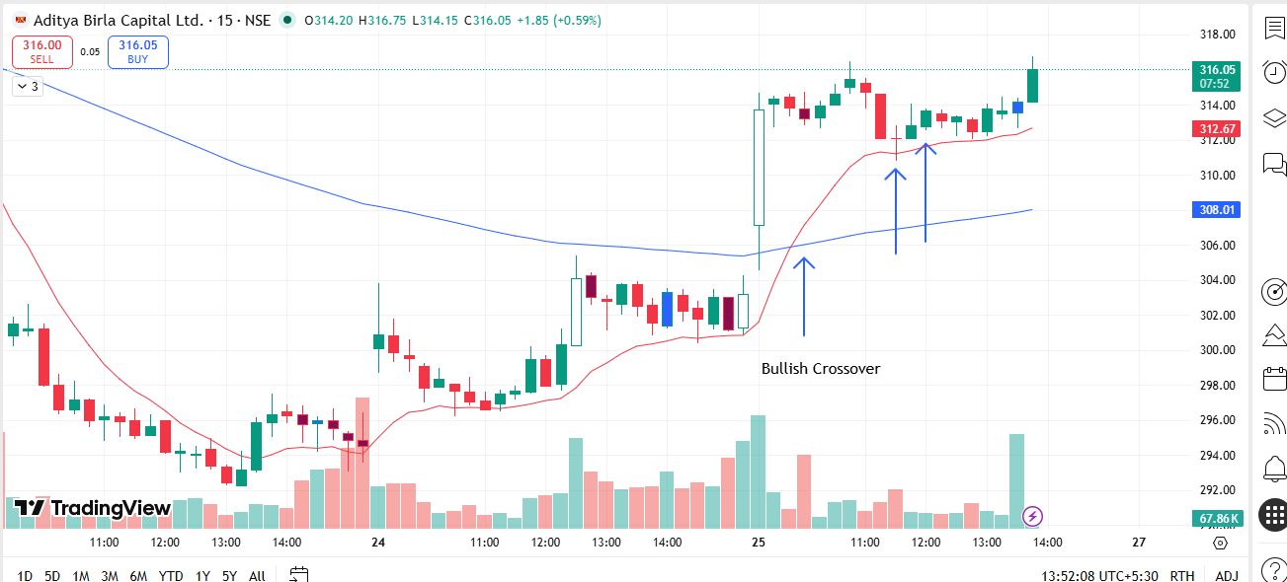
🟢 BULLISH SIGNAL --- AMBER
Crossover : 2026-03-25 09:45
Pullback : 2026-03-25 15:00
Confirm : 2026-03-25 15:15
Nifty Bias : ⚠️ CHOPPY (Choppy ⚠️)
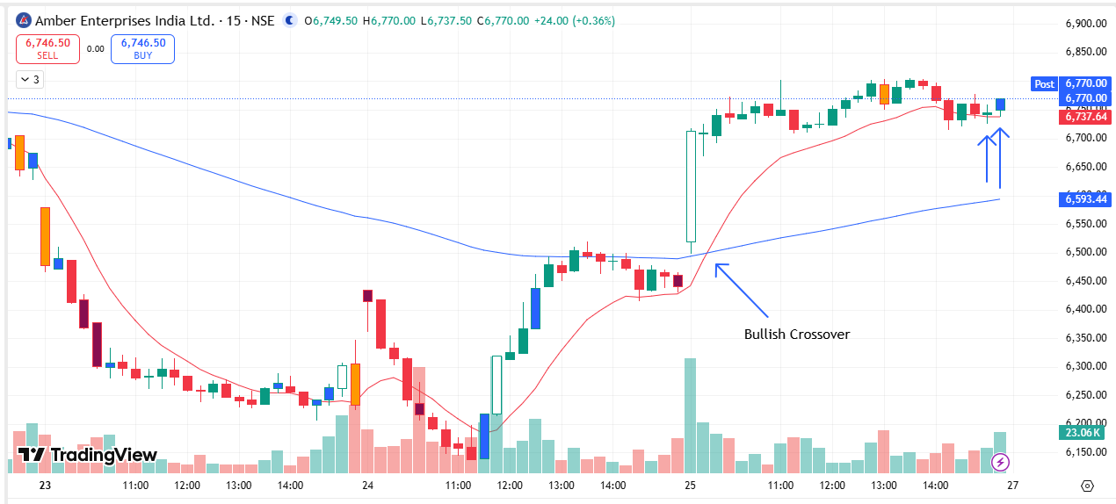
🟢 BULLISH SIGNAL --- AMBUJACEM
Crossover : 2026-03-25 09:45
Pullback : 2026-03-25 13:00
Confirm : 2026-03-25 13:45
Nifty Bias : ⚠️ CHOPPY (Choppy ⚠️)
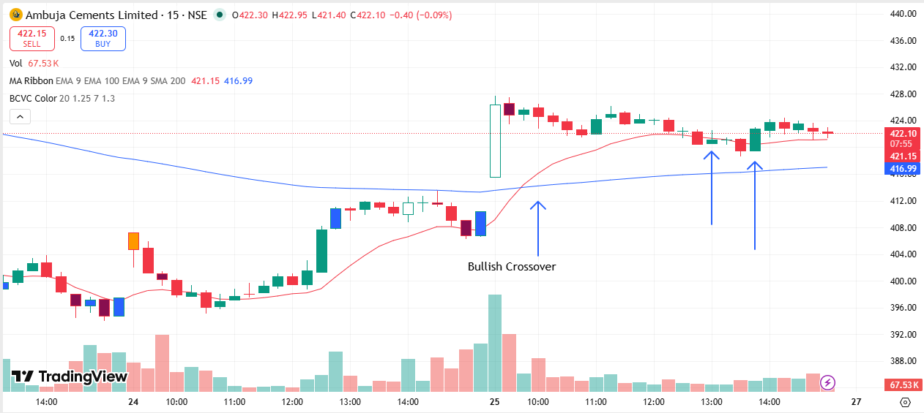
🟢 BULLISH SIGNAL --- APOLLOHOSP
Crossover : 2026-03-24 11:30
Pullback : 2026-03-25 14:15
Confirm : 2026-03-25 14:30
Nifty Bias : ⚠️ CHOPPY (Choppy ⚠️)
🟢 BULLISH SIGNAL --- ASHOKLEY
Crossover : 2026-03-25 09:30
Pullback : 2026-03-25 12:30
Confirm : 2026-03-25 13:15
Nifty Bias : ⚠️ CHOPPY (Choppy ⚠️)
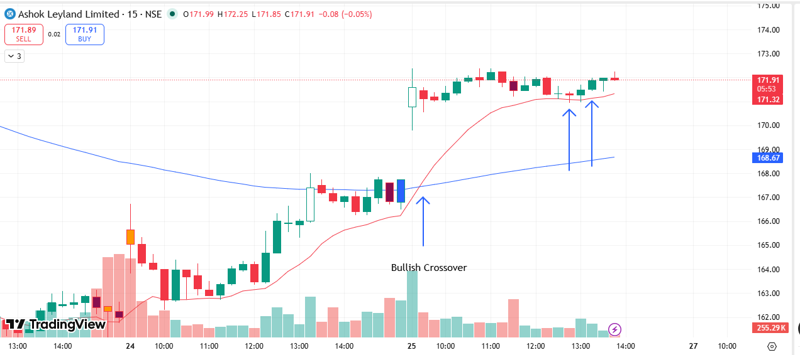
🟢 BULLISH SIGNAL --- ASIANPAINT
Crossover : 2026-03-24 13:00
Pullback : 2026-03-25 14:30
Confirm : 2026-03-25 14:45
Nifty Bias : ⚠️ CHOPPY (Choppy ⚠️)
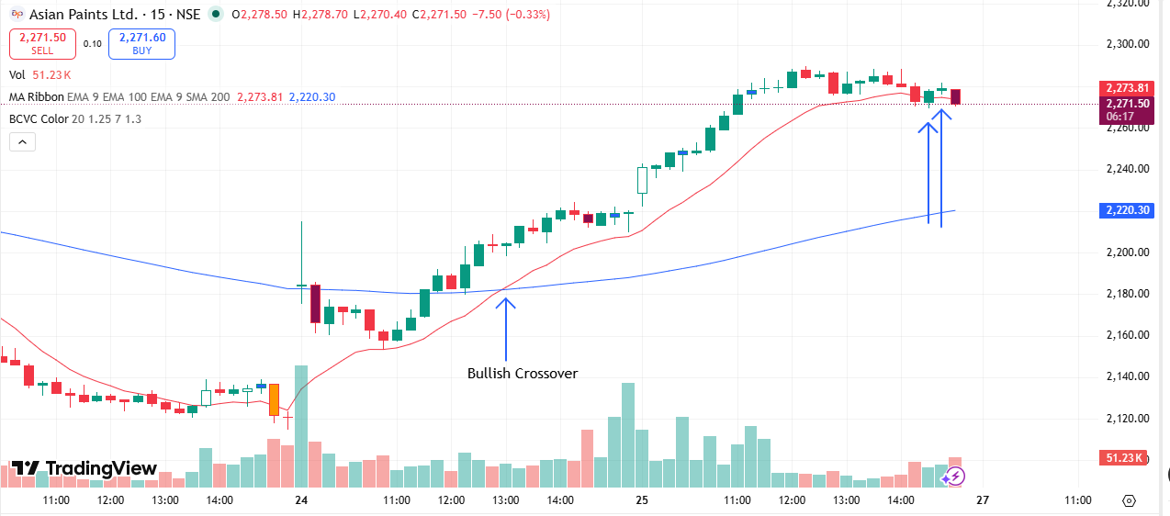
🟢 BULLISH SIGNAL --- AUROPHARMA
Crossover : 2026-03-24 15:00
Pullback : 2026-03-25 13:30
Confirm : 2026-03-25 14:00
Nifty Bias : ⚠️ CHOPPY (Choppy ⚠️)
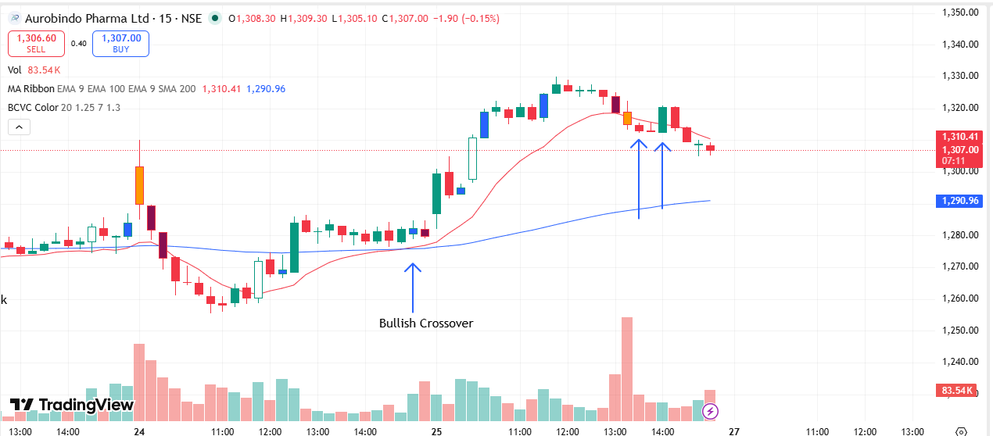
🟢 BULLISH SIGNAL --- DMART
Crossover : 2026-03-25 09:30
Pullback : 2026-03-25 14:15
Confirm : 2026-03-25 14:45
Nifty Bias : ⚠️ CHOPPY (Choppy ⚠️)
🟢 BULLISH SIGNAL --- BAJAJFINSV
Crossover : 2026-03-25 09:45
Pullback : 2026-03-25 13:45
Confirm : 2026-03-25 14:30
Nifty Bias : ⚠️ CHOPPY (Choppy ⚠️)
🟢 BULLISH SIGNAL --- BANKINDIA
Crossover : 2026-03-25 09:45
Pullback : 2026-03-25 14:30
Confirm : 2026-03-25 15:15
Nifty Bias : ⚠️ CHOPPY (Choppy ⚠️)
🟢 BULLISH SIGNAL --- BHEL
Crossover : 2026-03-24 13:00
Pullback : 2026-03-24 15:15
Confirm : 2026-03-25 09:15
Nifty Bias : ⚠️ CHOPPY (Choppy ⚠️)
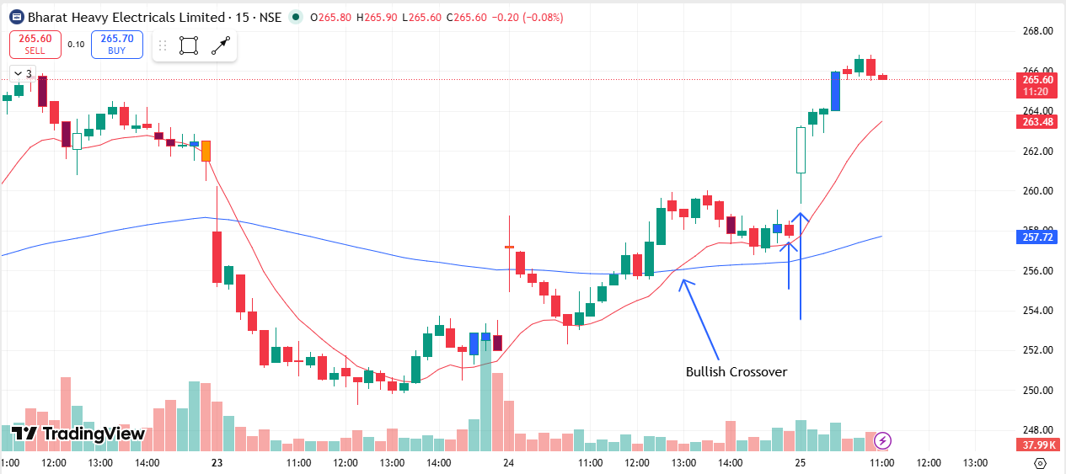
🟢 BULLISH SIGNAL --- BIOCON
Crossover : 2026-03-25 10:15
Pullback : 2026-03-25 13:30
Confirm : 2026-03-25 14:00
Nifty Bias : ⚠️ CHOPPY (Choppy ⚠️)
🟢 BULLISH SIGNAL --- BLUESTARCO
Crossover : 2026-03-25 10:00
Pullback : 2026-03-25 12:45
Confirm : 2026-03-25 13:15
Nifty Bias : ⚠️ CHOPPY (Choppy ⚠️)
🟢 BULLISH SIGNAL --- BOSCHLTD
Crossover : 2026-03-25 09:30
Pullback : 2026-03-25 11:30
Confirm : 2026-03-25 11:45
Nifty Bias : ⚠️ CHOPPY (Choppy ⚠️)
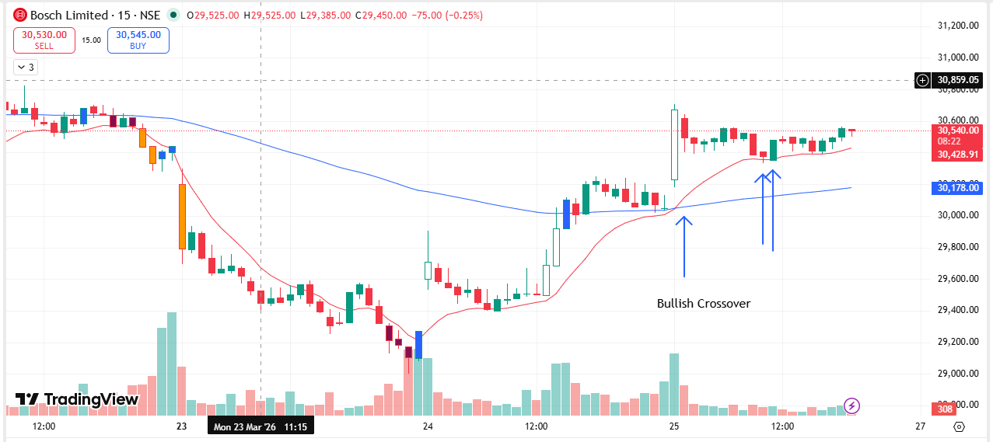
🟢 BULLISH SIGNAL --- CHOLAFIN
Crossover : 2026-03-25 09:45
Pullback : 2026-03-25 14:45
Confirm : 2026-03-25 15:00
Nifty Bias : ⚠️ CHOPPY (Choppy ⚠️)
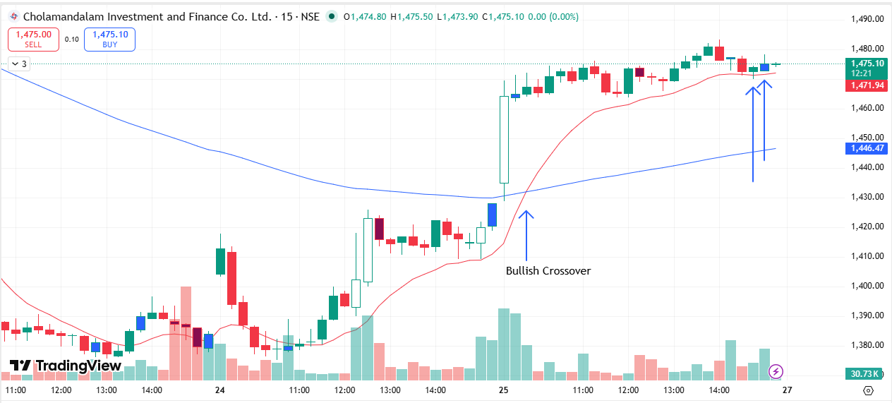
🟢 BULLISH SIGNAL --- COFORGE
Crossover : 2026-03-24 12:15
Pullback : 2026-03-24 14:45
Confirm : 2026-03-25 09:15
Nifty Bias : ⚠️ CHOPPY (Choppy ⚠️)
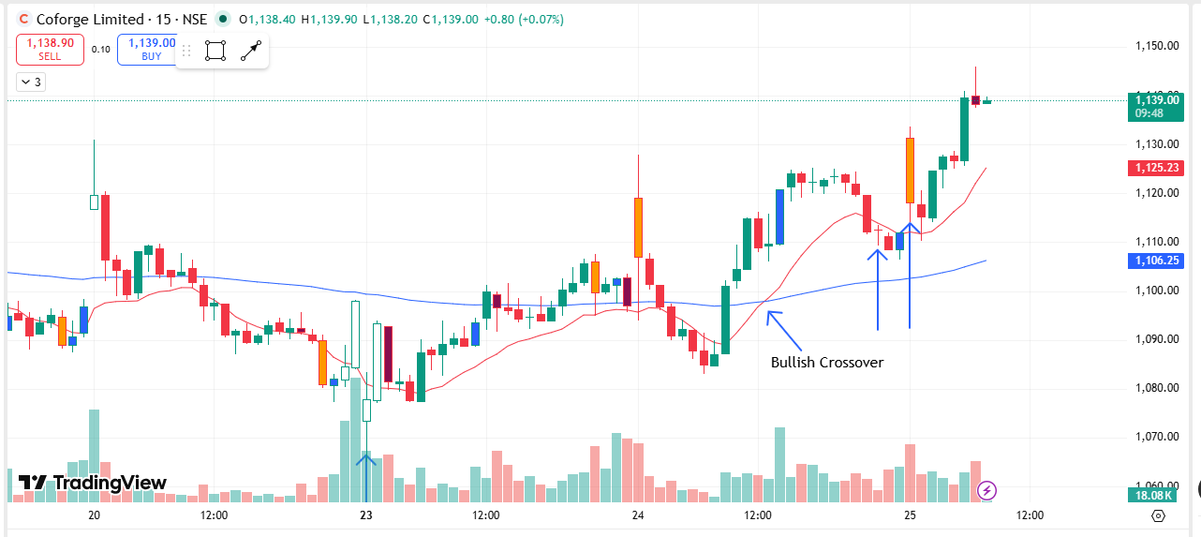
🟢 BULLISH SIGNAL --- COLPAL
Crossover : 2026-03-25 10:00
Pullback : 2026-03-25 14:15
Confirm : 2026-03-25 14:30
Nifty Bias : ⚠️ CHOPPY (Choppy ⚠️)
🟢 BULLISH SIGNAL --- CONCOR
Crossover : 2026-03-25 10:15
Pullback : 2026-03-25 12:45
Confirm : 2026-03-25 13:15
Nifty Bias : ⚠️ CHOPPY (Choppy ⚠️)
🟢 BULLISH SIGNAL --- CROMPTON
Crossover : 2026-03-25 10:15
Pullback : 2026-03-25 14:30
Confirm : 2026-03-25 15:15
Nifty Bias : ⚠️ CHOPPY (Choppy ⚠️)
🟢 BULLISH SIGNAL --- CUMMINSIND
Crossover : 2026-03-24 11:00
Pullback : 2026-03-24 15:00
Confirm : 2026-03-25 09:15
Nifty Bias : ⚠️ CHOPPY (Choppy ⚠️)
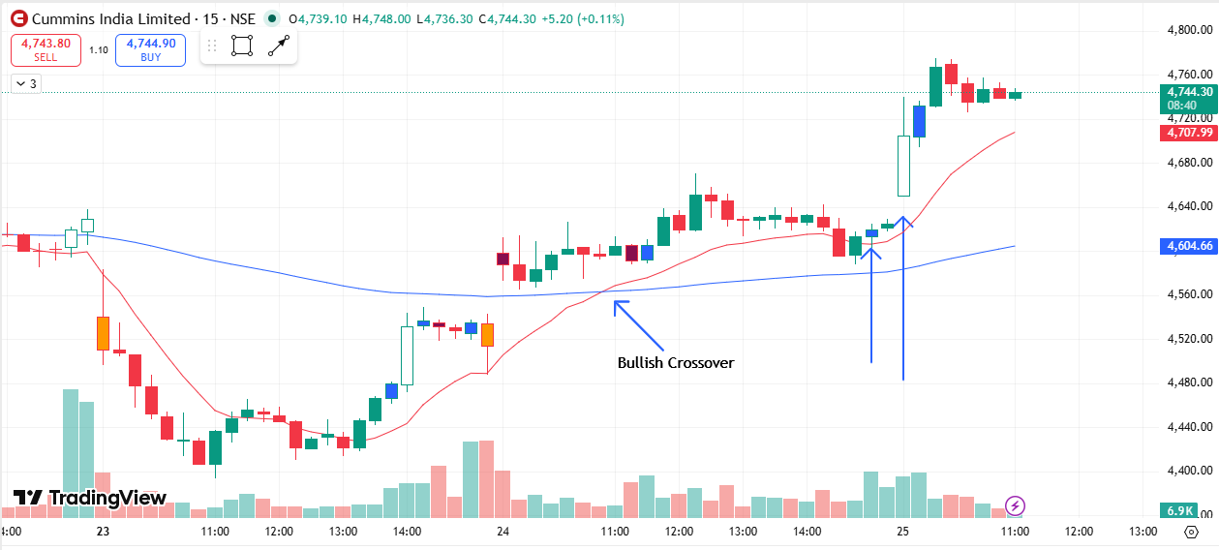
🟢 BULLISH SIGNAL --- DABUR
Crossover : 2026-03-25 12:00
Pullback : 2026-03-25 14:30
Confirm : 2026-03-25 14:45
Nifty Bias : ⚠️ CHOPPY (Choppy ⚠️)
🟢 BULLISH SIGNAL --- DELHIVERY
Crossover : 2026-03-24 12:45
Pullback : 2026-03-24 15:15
Confirm : 2026-03-25 09:15
Nifty Bias : ⚠️ CHOPPY (Choppy ⚠️)
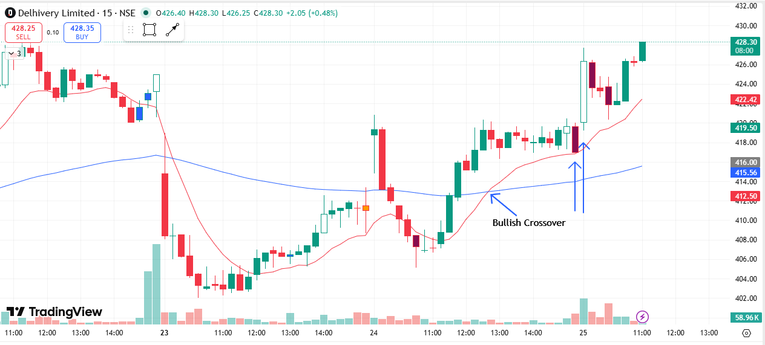
🟢 BULLISH SIGNAL --- DIXON
Crossover : 2026-03-25 09:30
Pullback : 2026-03-25 11:45
Confirm : 2026-03-25 12:30
Nifty Bias : ⚠️ CHOPPY (Choppy ⚠️)
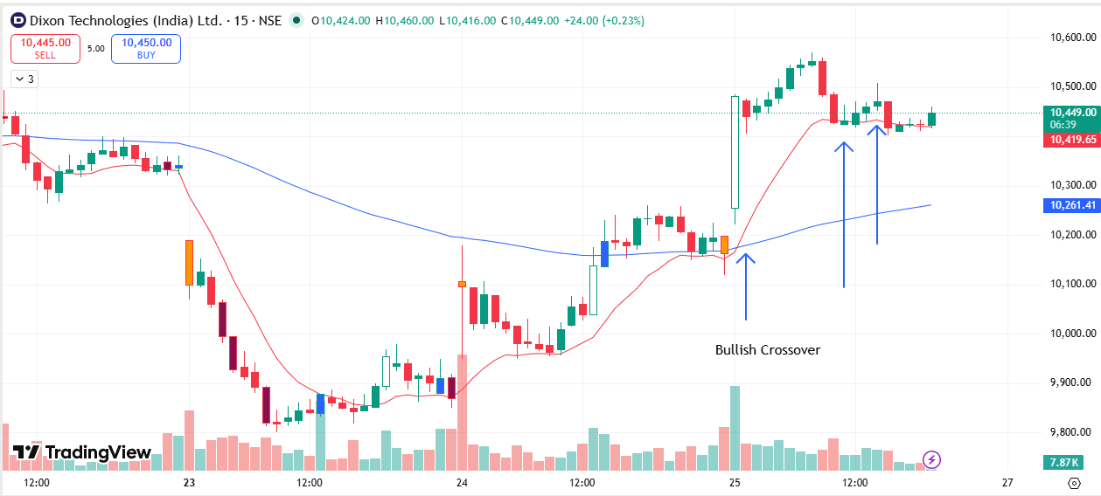
🟢 BULLISH SIGNAL --- DRREDDY
Crossover : 2026-03-25 10:30
Pullback : 2026-03-25 15:00
Confirm : 2026-03-25 15:15
Nifty Bias : ⚠️ CHOPPY (Choppy ⚠️)
🟢 BULLISH SIGNAL --- ETERNAL
Crossover : 2026-03-24 10:45
Pullback : 2026-03-25 12:30
Confirm : 2026-03-25 12:45
Nifty Bias : ⚠️ CHOPPY (Choppy ⚠️)
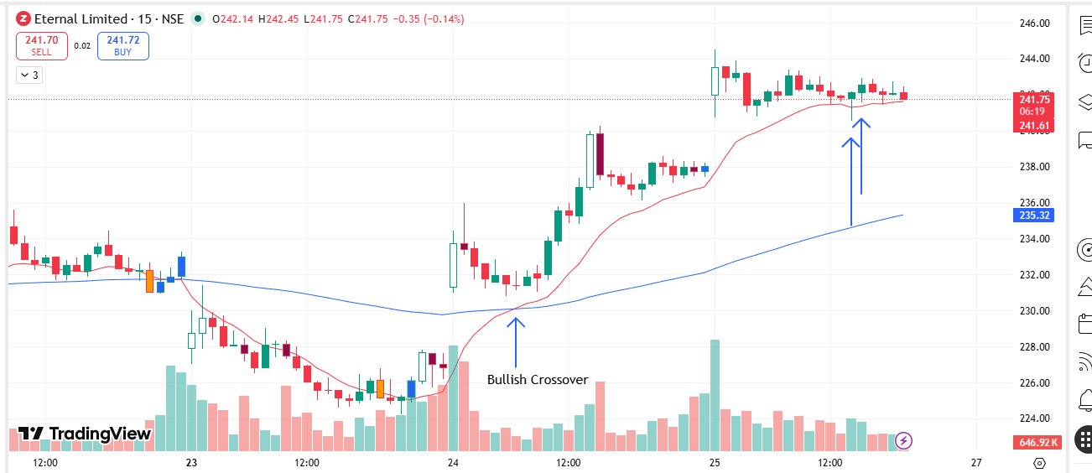
🟢 BULLISH SIGNAL --- EICHERMOT
Crossover : 2026-03-24 12:30
Pullback : 2026-03-24 14:45
Confirm : 2026-03-25 09:15
Nifty Bias : ⚠️ CHOPPY (Choppy ⚠️)
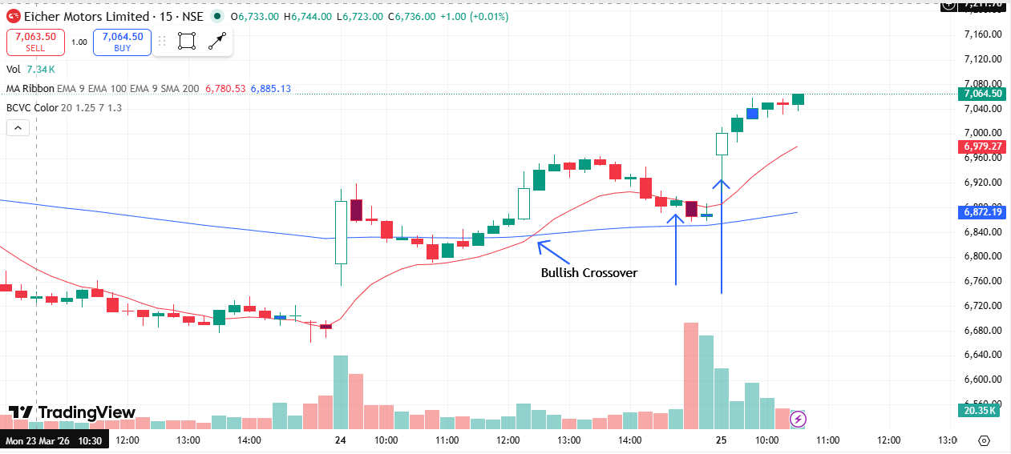
🟢 BULLISH SIGNAL --- NYKAA
Crossover : 2026-03-24 13:30
Pullback : 2026-03-24 15:00
Confirm : 2026-03-25 09:15
Nifty Bias : ⚠️ CHOPPY (Choppy ⚠️)
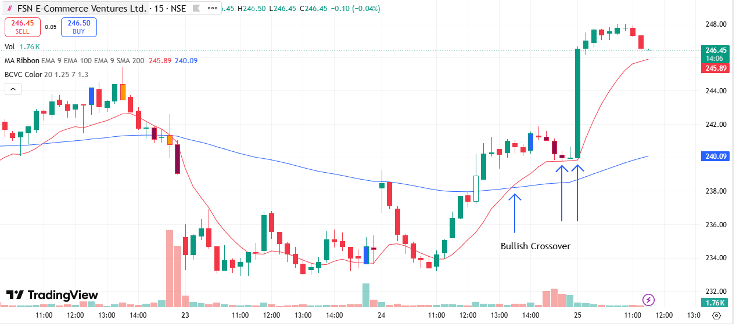
🟢 BULLISH SIGNAL --- FORTIS
Crossover : 2026-03-25 09:30
Pullback : 2026-03-25 13:15
Confirm : 2026-03-25 13:30
Nifty Bias : ⚠️ CHOPPY (Choppy ⚠️)
🟢 BULLISH SIGNAL --- GMRAIRPORT
Crossover : 2026-03-24 13:30
Pullback : 2026-03-24 15:15
Confirm : 2026-03-25 09:15
Nifty Bias : ⚠️ CHOPPY (Choppy ⚠️)
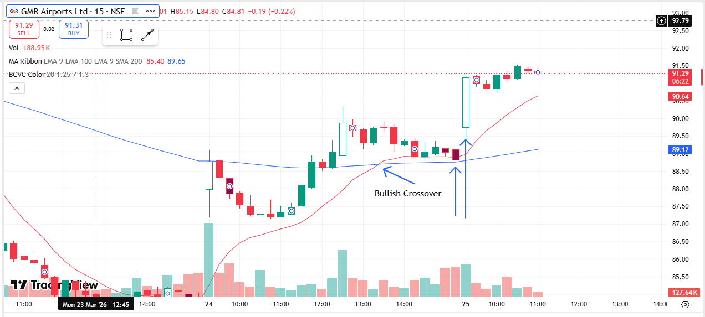
🟢 BULLISH SIGNAL --- GODREJPROP
Crossover : 2026-03-25 09:30
Pullback : 2026-03-25 12:45
Confirm : 2026-03-25 13:30
Nifty Bias : ⚠️ CHOPPY (Choppy ⚠️)
🟢 BULLISH SIGNAL --- GRASIM
Crossover : 2026-03-25 10:15
Pullback : 2026-03-25 15:00
Confirm : 2026-03-25 15:15
Nifty Bias : ⚠️ CHOPPY (Choppy ⚠️)
🟢 BULLISH SIGNAL --- HDFCAMC
Crossover : 2026-03-25 09:30
Pullback : 2026-03-25 13:30
Confirm : 2026-03-25 13:45
Nifty Bias : ⚠️ CHOPPY (Choppy ⚠️)
🟢 BULLISH SIGNAL --- HAVELLS
Crossover : 2026-03-25 10:45
Pullback : 2026-03-25 14:30
Confirm : 2026-03-25 15:15
Nifty Bias : ⚠️ CHOPPY (Choppy ⚠️)
🟢 BULLISH SIGNAL --- HEROMOTOCO
Crossover : 2026-03-24 13:30
Pullback : 2026-03-24 15:00
Confirm : 2026-03-25 09:15
Nifty Bias : ⚠️ CHOPPY (Choppy ⚠️)
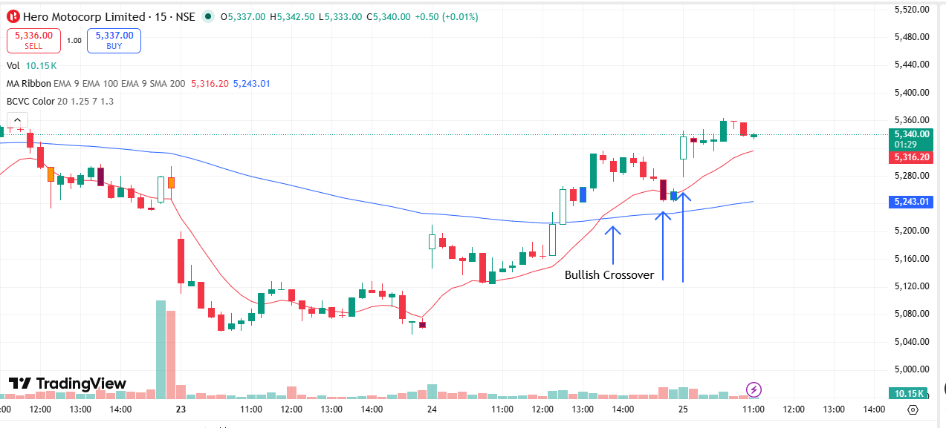
🟢 BULLISH SIGNAL --- HINDPETRO
Crossover : 2026-03-24 14:15
Pullback : 2026-03-25 11:45
Confirm : 2026-03-25 12:15
Nifty Bias : ⚠️ CHOPPY (Choppy ⚠️)
🟢 BULLISH SIGNAL --- HINDZINC
Crossover : 2026-03-25 10:15
Pullback : 2026-03-25 15:00
Confirm : 2026-03-25 15:15
Nifty Bias : ⚠️ CHOPPY (Choppy ⚠️)
🟢 BULLISH SIGNAL --- POWERINDIA
Crossover : 2026-03-24 11:45
Pullback : 2026-03-24 15:15
Confirm : 2026-03-25 09:15
Nifty Bias : ⚠️ CHOPPY (Choppy ⚠️)
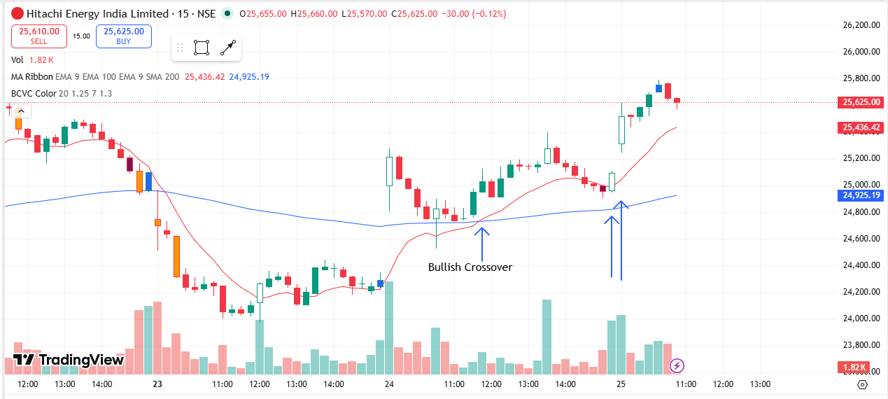
🟢 BULLISH SIGNAL --- IIFL
Crossover : 2026-03-25 10:15
Pullback : 2026-03-25 13:15
Confirm : 2026-03-25 13:30
Nifty Bias : ⚠️ CHOPPY (Choppy ⚠️)
🟢 BULLISH SIGNAL --- ITC
Crossover : 2026-03-25 12:00
Pullback : 2026-03-25 13:00
Confirm : 2026-03-25 13:45
Nifty Bias : ⚠️ CHOPPY (Choppy ⚠️)
🟢 BULLISH SIGNAL --- IEX
Crossover : 2026-03-24 14:45
Pullback : 2026-03-25 11:45
Confirm : 2026-03-25 12:30
Nifty Bias : ⚠️ CHOPPY (Choppy ⚠️)
🟢 BULLISH SIGNAL --- IRCTC
Crossover : 2026-03-25 10:00
Pullback : 2026-03-25 12:30
Confirm : 2026-03-25 13:15
Nifty Bias : ⚠️ CHOPPY (Choppy ⚠️)
🟢 BULLISH SIGNAL --- IREDA
Crossover : 2026-03-25 09:30
Pullback : 2026-03-25 14:30
Confirm : 2026-03-25 14:45
Nifty Bias : ⚠️ CHOPPY (Choppy ⚠️)
🟢 BULLISH SIGNAL --- INDUSINDBK
Crossover : 2026-03-25 10:00
Pullback : 2026-03-25 13:00
Confirm : 2026-03-25 13:15
Nifty Bias : ⚠️ CHOPPY (Choppy ⚠️)
🟢 BULLISH SIGNAL --- NAUKRI
Crossover : 2026-03-24 12:00
Pullback : 2026-03-24 15:00
Confirm : 2026-03-25 09:15
Nifty Bias : ⚠️ CHOPPY (Choppy ⚠️)
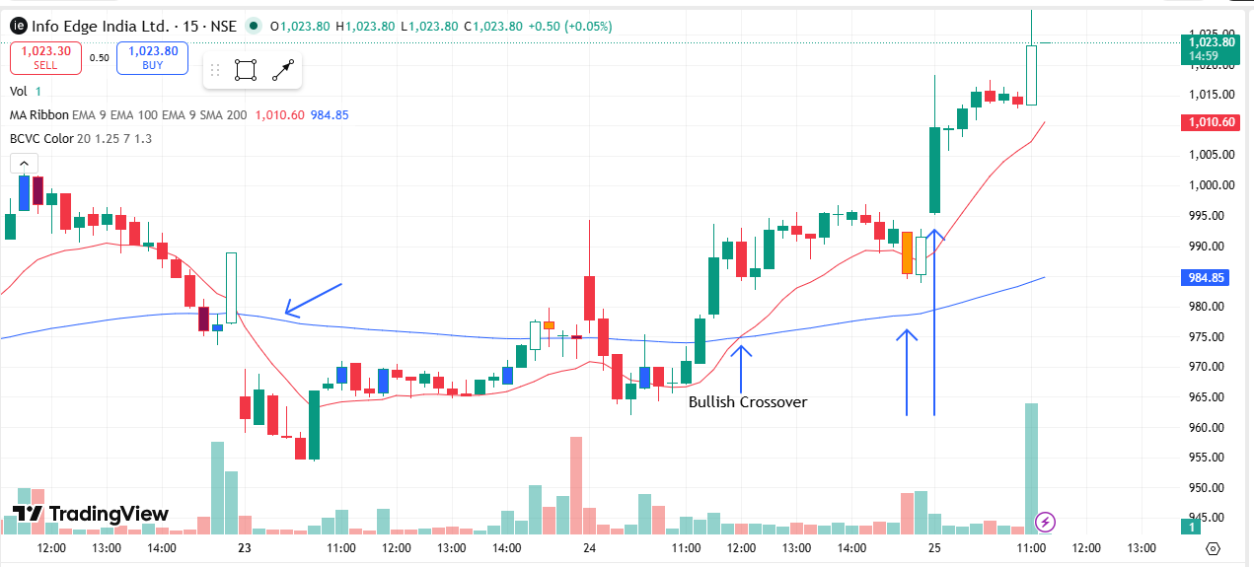
🟢 BULLISH SIGNAL --- INDIGO
Crossover : 2026-03-24 14:00
Pullback : 2026-03-25 12:45
Confirm : 2026-03-25 13:30
Nifty Bias : ⚠️ CHOPPY (Choppy ⚠️)
🟢 BULLISH SIGNAL --- JSWSTEEL
Crossover : 2026-03-25 09:45
Pullback : 2026-03-25 11:30
Confirm : 2026-03-25 12:00
Nifty Bias : ⚠️ CHOPPY (Choppy ⚠️)
🟢 BULLISH SIGNAL --- JUBLFOOD
Crossover : 2026-03-25 09:45
Pullback : 2026-03-25 13:45
Confirm : 2026-03-25 14:30
Nifty Bias : ⚠️ CHOPPY (Choppy ⚠️)
🟢 BULLISH SIGNAL --- KEI
Crossover : 2026-03-25 09:30
Pullback : 2026-03-25 12:30
Confirm : 2026-03-25 13:15
Nifty Bias : ⚠️ CHOPPY (Choppy ⚠️)
🟢 BULLISH SIGNAL --- KPITTECH
Crossover : 2026-03-24 13:30
Pullback : 2026-03-24 14:45
Confirm : 2026-03-25 09:15
Nifty Bias : ⚠️ CHOPPY (Choppy ⚠️)
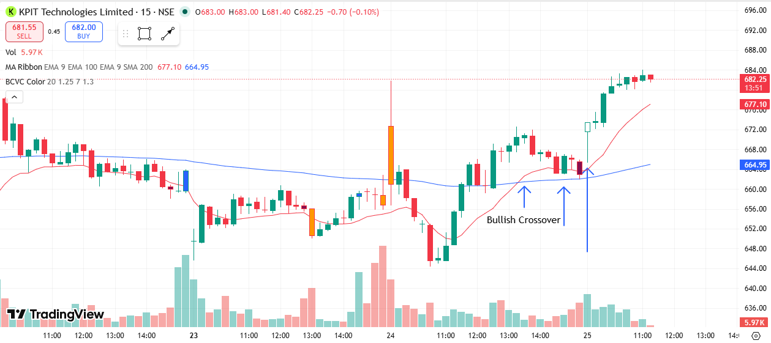
🟢 BULLISH SIGNAL --- KAYNES
Crossover : 2026-03-25 09:30
Pullback : 2026-03-25 12:45
Confirm : 2026-03-25 13:30
Nifty Bias : ⚠️ CHOPPY (Choppy ⚠️)
🟢 BULLISH SIGNAL --- KFINTECH
Crossover : 2026-03-24 13:15
Pullback : 2026-03-24 14:45
Confirm : 2026-03-25 09:15
Nifty Bias : ⚠️ CHOPPY (Choppy ⚠️)
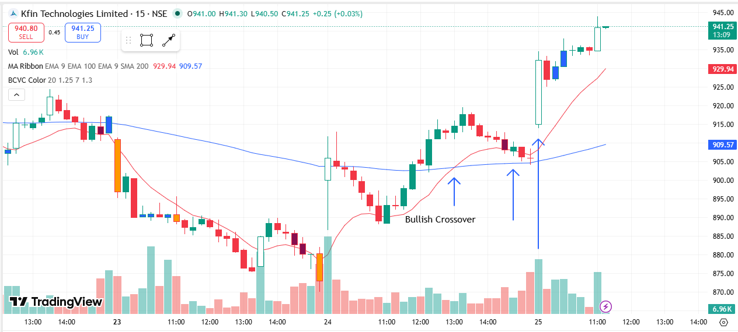
🟢 BULLISH SIGNAL --- LTM
Crossover : 2026-03-24 13:00
Pullback : 2026-03-24 15:15
Confirm : 2026-03-25 09:45
Nifty Bias : ⚠️ CHOPPY (Choppy ⚠️)
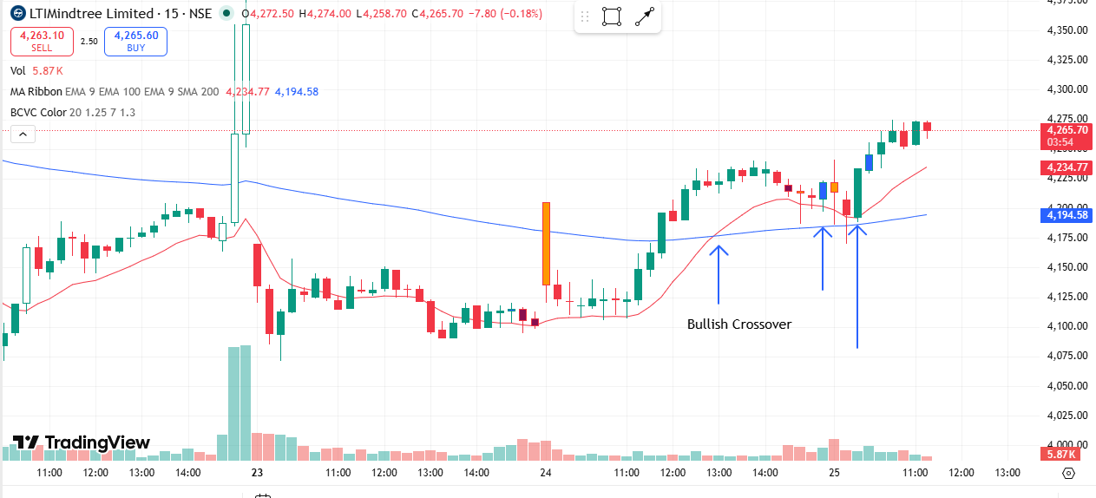
🟢 BULLISH SIGNAL --- LT
Crossover : 2026-03-24 13:00
Pullback : 2026-03-25 14:30
Confirm : 2026-03-25 15:15
Nifty Bias : ⚠️ CHOPPY (Choppy ⚠️)

🟢 BULLISH SIGNAL --- LAURUSLABS
Crossover : 2026-03-24 12:30
Pullback : 2026-03-24 14:45
Confirm : 2026-03-25 09:15
Nifty Bias : ⚠️ CHOPPY (Choppy ⚠️)
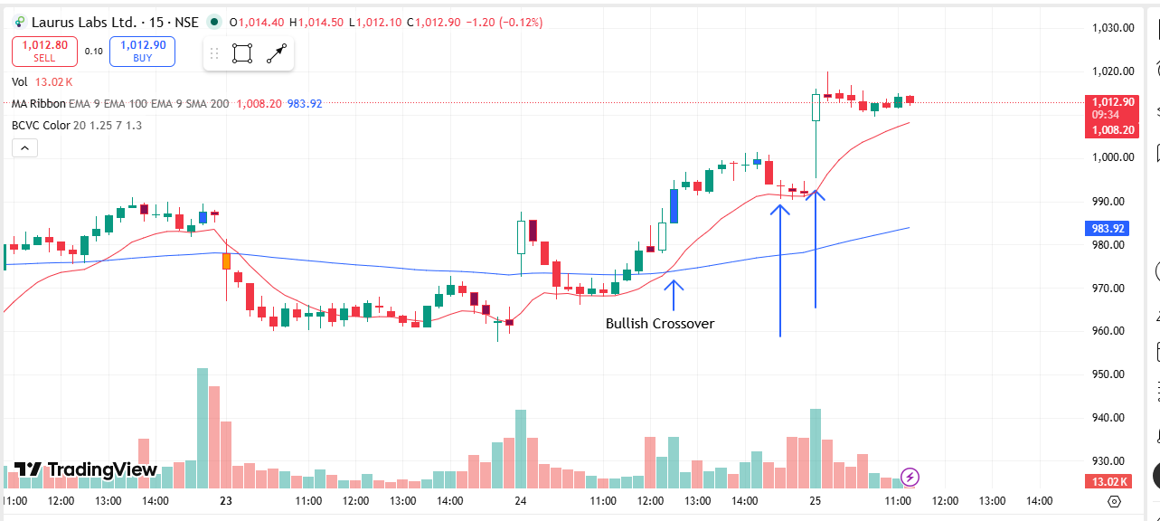
🟢 BULLISH SIGNAL --- LICI
Crossover : 2026-03-25 09:45
Pullback : 2026-03-25 13:15
Confirm : 2026-03-25 13:30
Nifty Bias : ⚠️ CHOPPY (Choppy ⚠️)
🟢 BULLISH SIGNAL --- LUPIN
Crossover : 2026-03-24 12:15
Pullback : 2026-03-24 14:45
Confirm : 2026-03-25 09:15
Nifty Bias : ⚠️ CHOPPY (Choppy ⚠️)
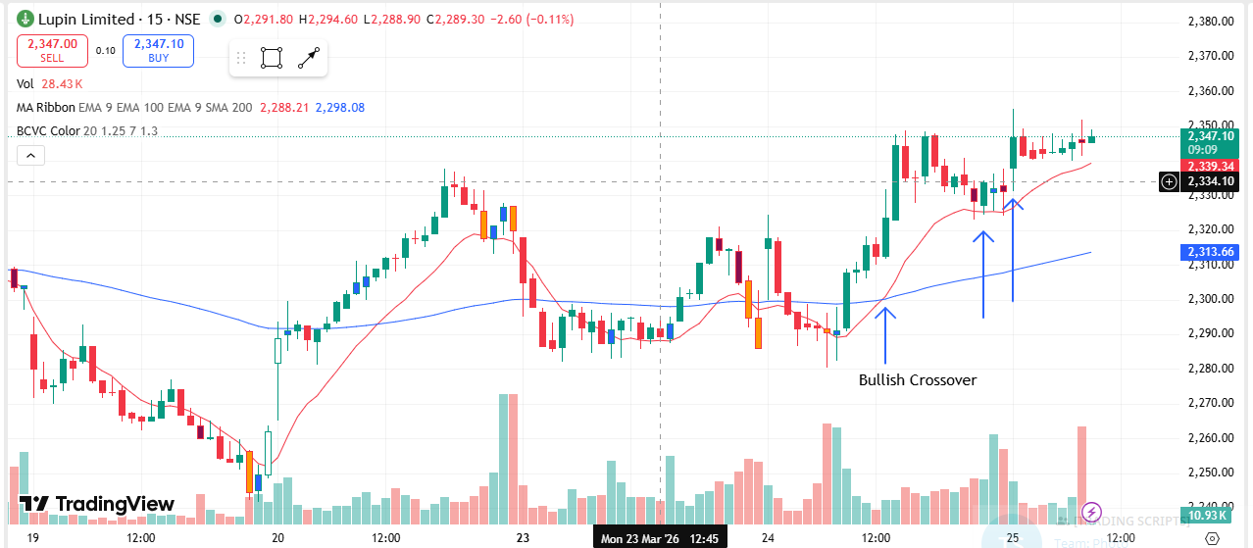
🟢 BULLISH SIGNAL --- MANAPPURAM
Crossover : 2026-03-25 09:45
Pullback : 2026-03-25 12:00
Confirm : 2026-03-25 12:15
Nifty Bias : ⚠️ CHOPPY (Choppy ⚠️)
🟢 BULLISH SIGNAL --- MANKIND
Crossover : 2026-03-25 10:00
Pullback : 2026-03-25 14:30
Confirm : 2026-03-25 15:15
Nifty Bias : ⚠️ CHOPPY (Choppy ⚠️)
🟢 BULLISH SIGNAL --- MARICO
Crossover : 2026-03-25 09:15
Pullback : 2026-03-25 10:45
Confirm : 2026-03-25 11:00
Nifty Bias : ⚠️ CHOPPY (Choppy ⚠️)
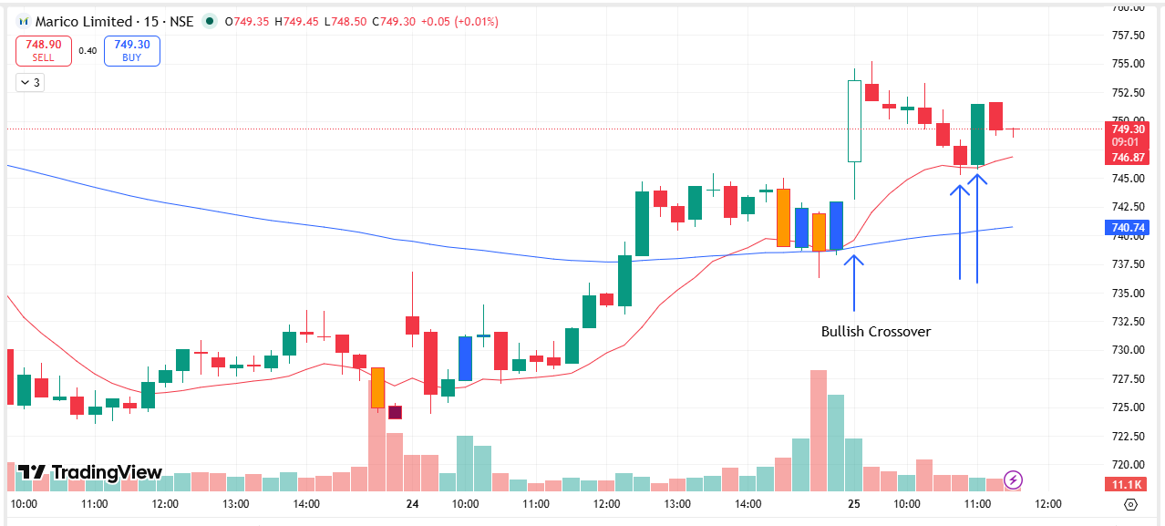
🟢 BULLISH SIGNAL --- MARUTI
Crossover : 2026-03-25 10:15
Pullback : 2026-03-25 13:00
Confirm : 2026-03-25 13:15
Nifty Bias : ⚠️ CHOPPY (Choppy ⚠️)
🟢 BULLISH SIGNAL --- MAXHEALTH
Crossover : 2026-03-24 10:45
Pullback : 2026-03-24 14:45
Confirm : 2026-03-25 09:15
Nifty Bias : ⚠️ CHOPPY (Choppy ⚠️)
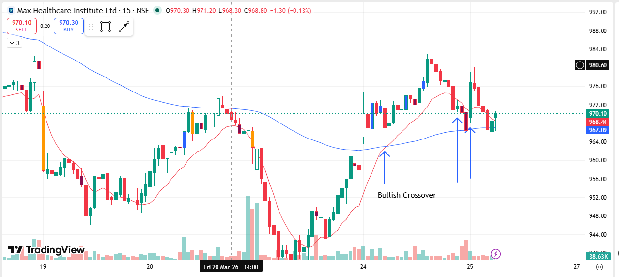
🟢 BULLISH SIGNAL --- MPHASIS
Crossover : 2026-03-24 12:00
Pullback : 2026-03-24 15:15
Confirm : 2026-03-25 09:45
Nifty Bias : ⚠️ CHOPPY (Choppy ⚠️)
🟢 BULLISH SIGNAL --- MUTHOOTFIN
Crossover : 2026-03-25 10:00
Pullback : 2026-03-25 11:30
Confirm : 2026-03-25 12:00
Nifty Bias : ⚠️ CHOPPY (Choppy ⚠️)
🟢 BULLISH SIGNAL --- NBCC
Crossover : 2026-03-25 09:45
Pullback : 2026-03-25 14:30
Confirm : 2026-03-25 14:45
Nifty Bias : ⚠️ CHOPPY (Choppy ⚠️)
🟢 BULLISH SIGNAL --- NCC
Crossover : 2026-03-25 10:00
Pullback : 2026-03-25 14:15
Confirm : 2026-03-25 14:30
Nifty Bias : ⚠️ CHOPPY (Choppy ⚠️)
🟢 BULLISH SIGNAL --- NHPC
Crossover : 2026-03-24 15:15
Pullback : 2026-03-25 13:00
Confirm : 2026-03-25 13:15
Nifty Bias : ⚠️ CHOPPY (Choppy ⚠️)
🟢 BULLISH SIGNAL --- NMDC
Crossover : 2026-03-25 10:00
Pullback : 2026-03-25 11:30
Confirm : 2026-03-25 12:00
Nifty Bias : ⚠️ CHOPPY (Choppy ⚠️)
🟢 BULLISH SIGNAL --- NTPC
Crossover : 2026-03-25 11:15
Pullback : 2026-03-25 14:15
Confirm : 2026-03-25 14:45
Nifty Bias : ⚠️ CHOPPY (Choppy ⚠️)
🟢 BULLISH SIGNAL --- NUVAMA
Crossover : 2026-03-24 13:30
Pullback : 2026-03-24 14:45
Confirm : 2026-03-25 09:15
Nifty Bias : ⚠️ CHOPPY (Choppy ⚠️)
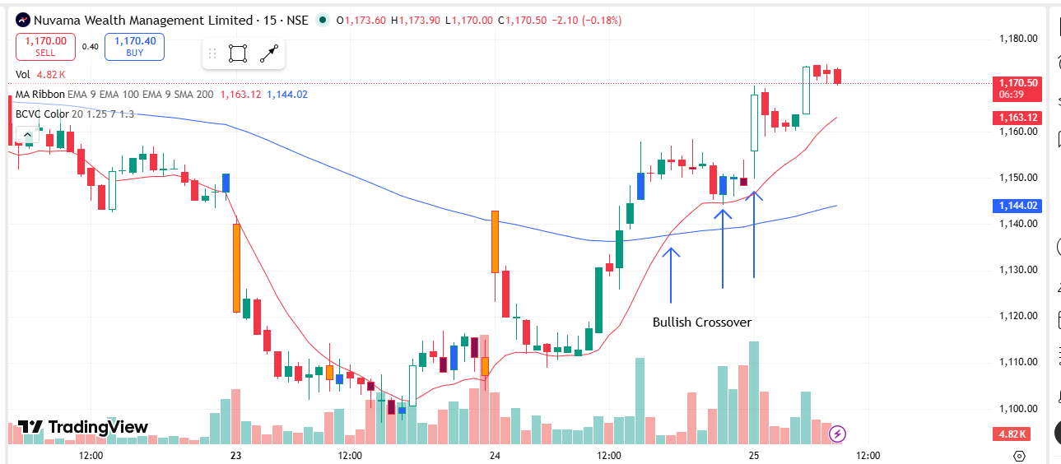
🟢 BULLISH SIGNAL --- OBEROIRLTY
Crossover : 2026-03-24 13:00
Pullback : 2026-03-24 15:15
Confirm : 2026-03-25 09:15
Nifty Bias : ⚠️ CHOPPY (Choppy ⚠️)
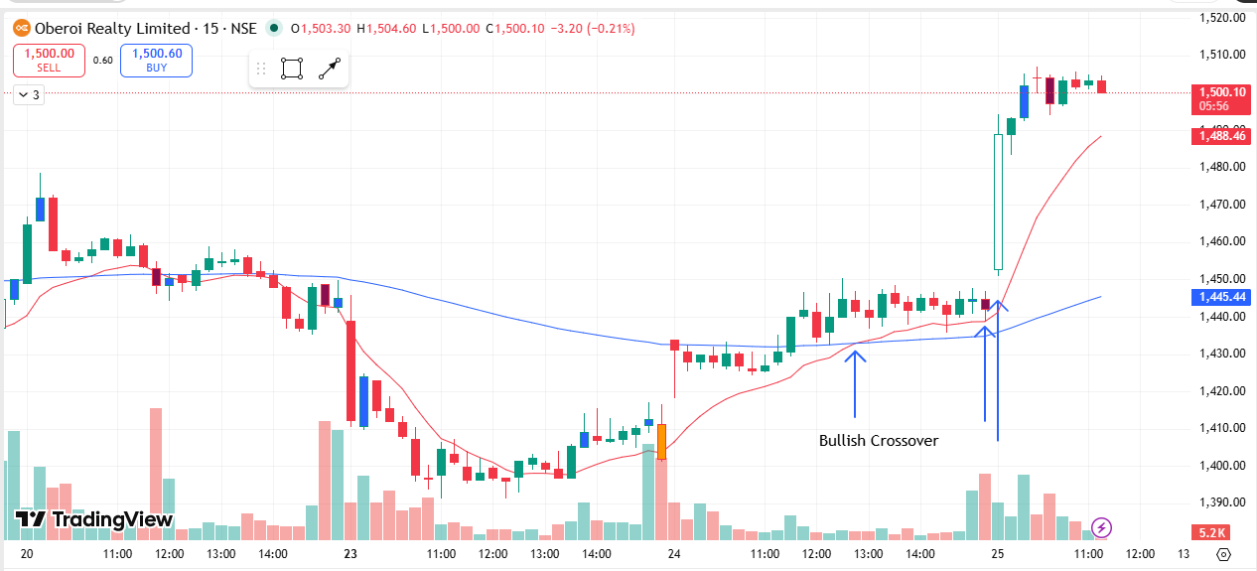
🟢 BULLISH SIGNAL --- PAYTM
Crossover : 2026-03-24 14:00
Pullback : 2026-03-25 14:15
Confirm : 2026-03-25 15:00
Nifty Bias : ⚠️ CHOPPY (Choppy ⚠️)
🟢 BULLISH SIGNAL --- PGEL
Crossover : 2026-03-25 09:30
Pullback : 2026-03-25 12:45
Confirm : 2026-03-25 13:30
Nifty Bias : ⚠️ CHOPPY (Choppy ⚠️)
🟢 BULLISH SIGNAL --- PNBHOUSING
Crossover : 2026-03-24 13:30
Pullback : 2026-03-24 15:00
Confirm : 2026-03-25 09:15
Nifty Bias : ⚠️ CHOPPY (Choppy ⚠️)
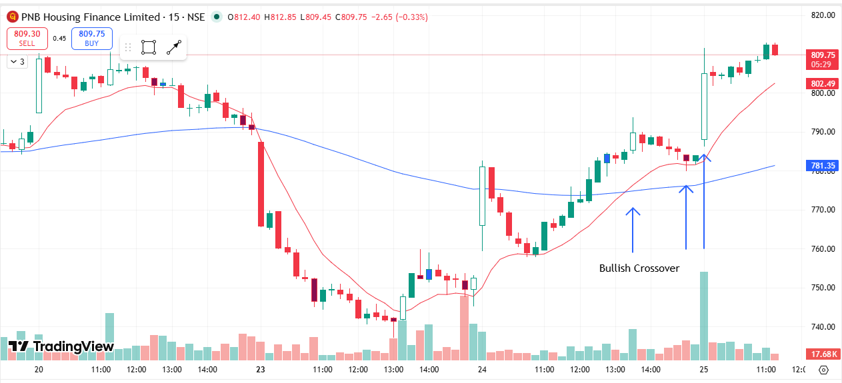
🟢 BULLISH SIGNAL --- PATANJALI
Crossover : 2026-03-25 10:30
Pullback : 2026-03-25 14:30
Confirm : 2026-03-25 15:15
Nifty Bias : ⚠️ CHOPPY (Choppy ⚠️)
🟢 BULLISH SIGNAL --- PIDILITIND
Crossover : 2026-03-24 13:30
Pullback : 2026-03-24 14:45
Confirm : 2026-03-25 09:15
Nifty Bias : ⚠️ CHOPPY (Choppy ⚠️)
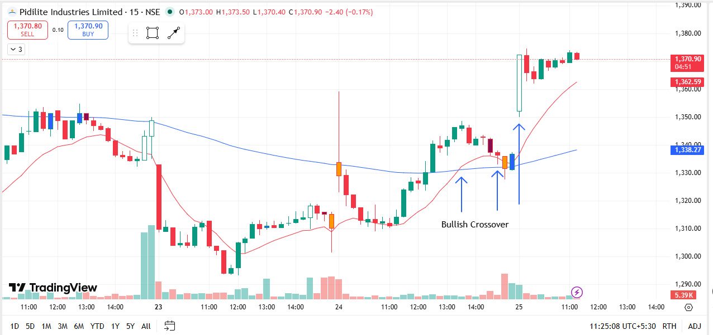
🟢 BULLISH SIGNAL --- POLYCAB
Crossover : 2026-03-24 14:30
Pullback : 2026-03-25 12:30
Confirm : 2026-03-25 13:15
Nifty Bias : ⚠️ CHOPPY (Choppy ⚠️)
🔴 BEARISH SIGNAL --- PFC
Crossover : 2026-03-25 14:15
Pullback : 2026-03-25 15:00
Confirm : 2026-03-25 15:15
Nifty Bias : ⚠️ CHOPPY (Choppy ⚠️)
🟢 BULLISH SIGNAL --- PNB
Crossover : 2026-03-25 11:45
Pullback : 2026-03-25 14:45
Confirm : 2026-03-25 15:15
Nifty Bias : ⚠️ CHOPPY (Choppy ⚠️)

🟢 BULLISH SIGNAL --- RECLTD
Crossover : 2026-03-25 10:45
Pullback : 2026-03-25 14:15
Confirm : 2026-03-25 14:45
Nifty Bias : ⚠️ CHOPPY (Choppy ⚠️)
🟢 BULLISH SIGNAL --- RELIANCE
Crossover : 2026-03-24 10:00
Pullback : 2026-03-24 15:15
Confirm : 2026-03-25 09:15
Nifty Bias : ⚠️ CHOPPY (Choppy ⚠️)
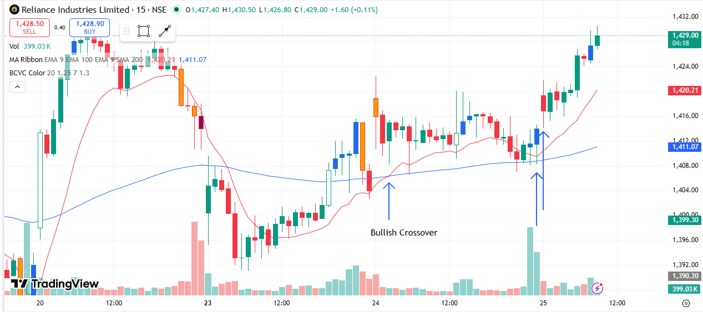
🟢 BULLISH SIGNAL --- SHREECEM
Crossover : 2026-03-24 14:15
Pullback : 2026-03-25 14:15
Confirm : 2026-03-25 14:30
Nifty Bias : ⚠️ CHOPPY (Choppy ⚠️)
🟢 BULLISH SIGNAL --- SRF
Crossover : 2026-03-24 14:30
Pullback : 2026-03-25 15:00
Confirm : 2026-03-25 15:15
Nifty Bias : ⚠️ CHOPPY (Choppy ⚠️)
🟢 BULLISH SIGNAL --- SAMMAANCAP
Crossover : 2026-03-24 13:45
Pullback : 2026-03-25 13:00
Confirm : 2026-03-25 13:30
Nifty Bias : ⚠️ CHOPPY (Choppy ⚠️)
🟢 BULLISH SIGNAL --- SIEMENS
Crossover : 2026-03-25 10:45
Pullback : 2026-03-25 14:30
Confirm : 2026-03-25 14:45
Nifty Bias : ⚠️ CHOPPY (Choppy ⚠️)
🟢 BULLISH SIGNAL --- SOLARINDS
Crossover : 2026-03-25 10:30
Pullback : 2026-03-25 13:00
Confirm : 2026-03-25 13:30
Nifty Bias : ⚠️ CHOPPY (Choppy ⚠️)
🟢 BULLISH SIGNAL --- SBIN
Crossover : 2026-03-25 10:45
Pullback : 2026-03-25 14:15
Confirm : 2026-03-25 14:45
Nifty Bias : ⚠️ CHOPPY (Choppy ⚠️)
🟢 BULLISH SIGNAL --- SUNPHARMA
Crossover : 2026-03-25 11:00
Pullback : 2026-03-25 15:00
Confirm : 2026-03-25 15:15
Nifty Bias : ⚠️ CHOPPY (Choppy ⚠️)
🟢 BULLISH SIGNAL --- SUPREMEIND
Crossover : 2026-03-25 09:45
Pullback : 2026-03-25 12:15
Confirm : 2026-03-25 12:30
Nifty Bias : ⚠️ CHOPPY (Choppy ⚠️)
🟢 BULLISH SIGNAL --- TATACONSUM
Crossover : 2026-03-25 09:30
Pullback : 2026-03-25 10:45
Confirm : 2026-03-25 11:00
Nifty Bias : ⚠️ CHOPPY (Choppy ⚠️)
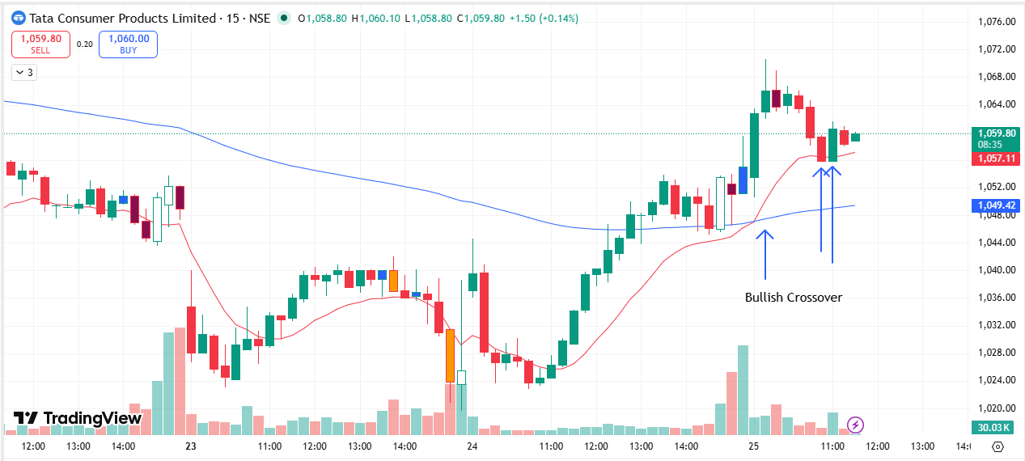
🟢 BULLISH SIGNAL --- TVSMOTOR
Crossover : 2026-03-24 13:15
Pullback : 2026-03-25 11:15
Confirm : 2026-03-25 11:45
Nifty Bias : ⚠️ CHOPPY (Choppy ⚠️)

📊 TRADING SUMMARY
━━ ALL TRADES (26-Mar) ━━━━━━━━━━━━━━━━━━━━
Total Signals | 100
Taken Trades | 00
Not Taken | 100
Balance | Rs. 1,09,75,128.40
Current Balance | Rs. 1,09,27,812.86

━━ TODAY'S LIVE TRADING (26-Mar) ━━━━━━━━━━━━━━━━━━━━
Total | 0
Completed | 00
Wins ✅ | 0
Losses ❌ | 0
Open ⏳ | 0
Win Rate | 0.0%
Net P/L | +Rs. 0.00 , +0.00 pts
Brokerage | Rs. 0.00
Taxes & Fees | Rs. 0.00

━━ ALL-TIME LIVE TRADING ━━━━━━━━━━━━━━━━━━━━
Completed | 19
Wins ✅ | 5
Losses ❌ | 14
Open ⏳ | 4
Win Rate | 26.3%
Net P/L | -Rs. 47,315.54 , -88,580.00 pts
Brokerage | Rs. 1520.00
Taxes & Fees | Rs. 6051.08

━━ TODAY'S BACKTEST (26-Mar) ━━━━━━━━━━━━━━━━━━━━
Signals Today | 0
Resolved | 0
TARGET HIT ✅ | 0
SL HIT ❌ | 0
Open ⏳ | 0
Win Rate | 0.0%
Total PnL | +0.00 pts

━━ ALL-TIME BACKTEST SUMMARY ━━━━━━━━━━━━━━━━━━━━
Total Signals | 280
TARGET HIT ✅ | 148
SL HIT ❌ | 96
Open ⏳ | 36
Win Rate | 60.7%
Total PnL | +1,676.98 pts

🤖 TRADE BEHAVIOUR ANALYSIS
✅ Trades Taken — What signals fired:
1. BSE — Bullish crossover, Nifty choppy. Entry ₹2843.7, SL ₹2816.
2. BANDHANBNK — Bullish crossover, Nifty choppy. Entry ₹154.19, SL ₹153.55.
3. BHARATFORG — Bullish crossover, Nifty choppy. Entry ₹1749.1, SL ₹1700.3.
4. CAMS — Bullish crossover, Nifty choppy. Entry ₹651.55, SL ₹634.8.
5. OFSS — Bullish crossover, Nifty choppy. Entry ₹6635, SL ₹6604.5.
⛔ Trades Not Taken (95 signals skipped):
Nifty choppy — skipped (95): ABB, APLAPOLLO, ADANIENT, ADANIGREEN, ADANIPORTS, ABCAPITAL, AMBER, AMBUJACEM, APOLLOHOSP, ASHOKLEY, ASIANPAINT, AUROPHARMA, DMART, BAJAJFINSV, BANKINDIA, BHEL, BIOCON, BLUESTARCO, BOSCHLTD, CHOLAFIN, COFORGE, COLPAL, CONCOR, CROMPTON, CUMMINSIND, DABUR, DELHIVERY, DIXON, DRREDDY, ETERNAL, EICHERMOT, NYKAA, FORTIS, GMRAIRPORT, GODREJPROP, GRASIM, HDFCAMC, HAVELLS, HEROMOTOCO, HINDPETRO, HINDZINC, POWERINDIA, IIFL, ITC, IEX, IRCTC, IREDA, INDUSINDBK, NAUKRI, INDIGO, JSWSTEEL, JUBLFOOD, KEI, KPITTECH, KAYNES, KFINTECH, LTM, LT, LAURUSLABS, LICI, LUPIN, MANAPPURAM, MANKIND, MARICO, MARUTI, MAXHEALTH, MPHASIS, MUTHOOTFIN, NBCC, NCC, NHPC, NMDC, NTPC, NUVAMA, OBEROIRLTY, PAYTM, PGEL, PNBHOUSING, PATANJALI, PIDILITIND, POLYCAB, PFC, PNB, RECLTD, RELIANCE, SHREECEM, SRF, SAMMAANCAP, SIEMENS, SOLARINDS, SBIN, SUNPHARMA, SUPREMEIND, TATACONSUM, TVSMOTOR
📝 95% of today's signals were not acted on. 95 fired during choppy Nifty conditions — high noise, wise to skip.

